**Hackathon DAY 7**

**LIVE DEPLOYMENT AND POST LAUNCH PRACTICES**

**Environment variable securely configure:**

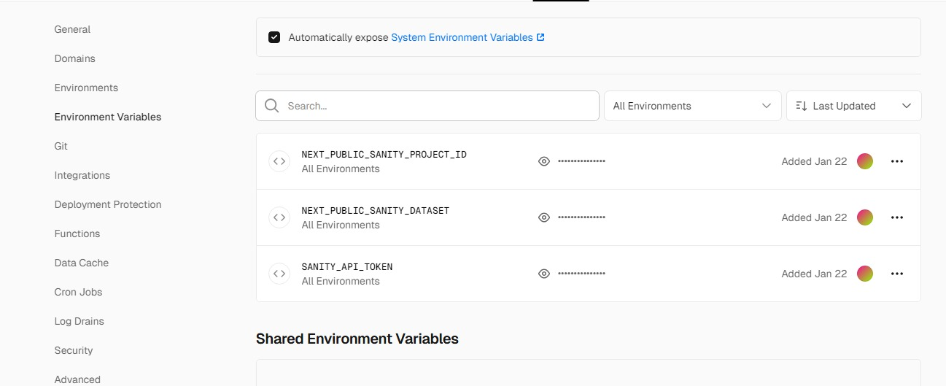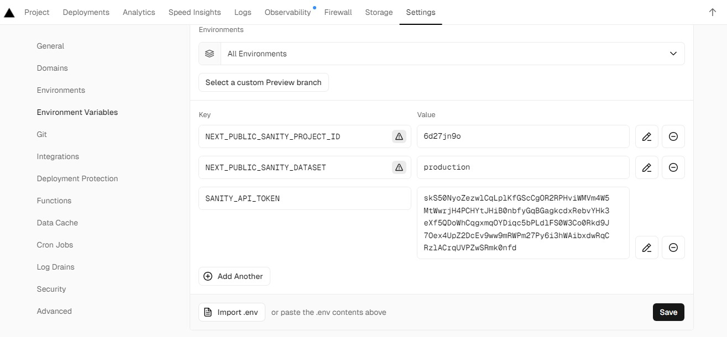

**SSL and HTTPS Enable:**

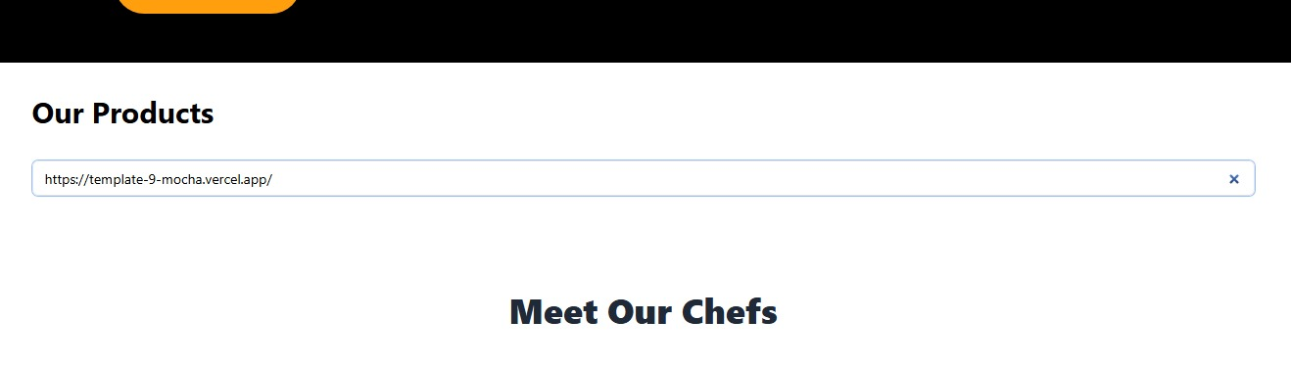 PP

**Performance Optimization:**

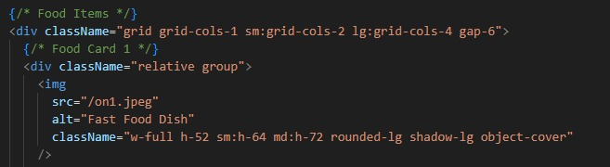

**Monitoring and Analytics Tools:**

* Vercel Analytics
* Use tools like **Sentry**
* Npm install @sentry/nextjs

